Lesson Plan: Body Positions
Learning Objective:  I can move my body into many positions.  I can balance my body in many positions, such as straight, pike, tuck, straddle, squat, lunge, prone, and supine.  I can identify the names of different positions and get my body into them when ask to show each body position.  I can use different body positions as part of other skills and movement.  I can identify when different body positions are used in other movements. | Lesson Notes:  The body positions being introduced in this lesson are foundational positions that are used across the lifespan during physical activity. This lesson focuses on introduce students to how to execute each body position and identify the correct name of each.  Body position vocabulary is part of a greater effort toward integrating reading literacy into the movement literacy environment of physical education class through use of a word wall. Flash cards give a written name to the skills being taught, and elevate the language that is used in a movement environment throughout the life continuum. This practice also allows students to experience natural transfers of physical education concepts and skills to their use in the rest of their world.  The words that students see attached to each body position assist them in making connections to sight words which eventually become part of their reading and movement vocabulary. This practice sets the stage for lifelong use of exercise/activity words that are appropriate across the lifespan.  Aligned assessments can be used as tools when practicing the body positions following the lesson and extend learning in an ongoing basis.  Materials:  Body Position Flash Cards, printed on card stock, one set/2 students  Body Position Formative Assessment (Peer Observation), one/student  Body Position Summative Assessment, one/student  Pencils, one/student  Posted Peer Coaching Guidelines- see below. Posted cues can be simple bullet points once students have experience using the protocols.  Peer Coaching  - Watch your partner perform the skill.  - Tell your partner something good that they did. Be specific.  - Give your partner a good tip for improving. Use the correct cues or words.  - Make success together your goal for today.

Standard of Learning: Motor Skill Development
1.1 The student will demonstrate approaching mature form and the correct critical elements (small, isolated parts of the whole skill or movement) of locomotor, non-locomotor, and manipulative skills.

e. Demonstrate simple educational gymnastic skills, to include balancing at different levels, two different rolls (narrow or curled), moving in two different directions, and transfer of weight.

Link to Background Knowledge
Students should have previous knowledge of:
- Finding good personal space in general space
- Peer-coaching protocols used in class, which include practice locations/formations and feedback practices
- Non-manipulative balancing skills
- Understanding of creating a strong base for balancing
- Basic experience with movement vocabulary: forward, backward, up, down, overhead, wide, narrow, curved, big, small, tight.
- Ability to identify body parts
- Ability to balance on different body parts
- Changing from one body shape to another
- Curling and twisting
- Basic stretches used to stretch the muscles
Engage and Explain What is the knowledge or skill that students will need to be successful in meeting the learning objective?
Today we are going to learn eight body positions that you are going to use forever-for the rest of your life! First let’s talk about what you will need to think about as we practice these body positions.

Set induction: Have you ever played the game statue? When you play statue, it is really important to freeze like a popsicle and not move. Today, when we first practice these body positions, we are going to freeze in each position so that we can think about what our bodies are doing to hold the position. It’s almost as if we are taking a picture of you while you are doing this. Your peer coach is going to be checking on you later to make sure that you remember what each position is, what it looks like, and how to make your body get into the position.

As you instruct each position, post the flash card on the wall in the instructional area, or if already posted, point to it-this works great with a classroom magic wand. Ask students to spell the word with you and pronounce it. Use established reading practices used by the school. Remind students to create a strong base of support for whatever body part is in contact with the floor. As you deliver the prompts during instruction, make sure to relate each body position to activities that are part of the students’ life experiences. This link to emotional learning will help them remember these new body positions/cues for future use.

Straight: The first position is a straight body position. Show me what you think straight means. Cue: Popsicle. Your arms can be by your side or stretched high overhead; you will use this position both ways as you learn to move in many other ways. Can you find another way to make your body straight but not be standing on your feet?

Supine: When you lay on your back with your face (or belly button) looking up at the sky, you are in a supine position. Can you think of activities that you might do that start in a supine position, or your body moves through a supine position? (log roll, sit up) Let’s try some. Direct students through some student-generated examples.

Prone: When you lay on the ground with your face (or belly button) facing down to the ground, you are in a prone position. Can you show me an activity that we do that starts in a prone position? (Superman, inchworm, creeping, crawling). Let’s try some. Direct students through some student-generated examples.

Pike: A pike position is when you reach your hands all the way to your toes. Your legs are straight, and you fold in half as tightly as you can. Show me a pike! Can you name something we do in a pike position? (stretch, sit and reach, standing and touching your toes) So a pike can be made with your body in different ways. You can sit on the floor and reach forward, or stand on your feet and reach for the floor. Are there any other ways you can perform a pike? Show me! Yes, you can lie on your side and pike-try that, or you can lie on the floor in a supine position and bring your legs over your body and bring your toes back to your hands-try that one too. Well done!

Tuck: A tuck position is when you bring your knees into your chest very tightly and your body curves forward into the smallest ball you can become-show me your best tuck! How many different ways can you make a tuck? Show me.

Straddle: A straddle position is when you make your legs move apart from each other. You can make a wide straddle-let’s try that, and you can make a narrow straddle-try that too. You can make a straddle during movement, or when you are in other positions. Can you think of activities you do where you might use a straddle? (jumping jacks, angels in the snow, swimming) Let’s try some. Direct students through some student-generated examples.

Squat: A squat position is when you bend your knees and start to sit back, like you are going to sit in a chair, but you still use your feet as a base of support. Think of an elevator going down. Start bending you knees and get halfway down as far as you can. Stop. Look forward and try to balance and hold this position. Now slowly squat lower until you can’t go any further, balance there. Can you think of any activities we do that use a squat position? Let’s try some. Direct students through some student-generated examples.

Lunge: A lunge position is where one leg is positioned forward with your knee bent and foot flat on the ground while the other leg is positioned behind you, with your weight on the front part of your foot. You will want to keep your feet about shoulder-width apart so that you have a strong base of support. Try making a lunge with your right leg in the front. Let’s try and balance for 10 seconds. Don’t forget to find a spot on the wall and stare at it to keep your balance.

Let’s try that again with your left foot in front. You can also make a lunge move to the side-take a big step to the right with your right leg, and bend it. Keep your left leg straight-can you try holding that for ten seconds? Now try that to the left side; your left foot takes a big step left, and your right leg stays straight. Hold it-is that easy to do or hard? Do you have any tips for keeping your balance?

You will use a lunge position for many activities. Can you think of some activities you do now that use a lunge position? (stretching, stepping forward when you throw, spotting position when spotting somebody who is climbing on the horizontal climbing wall)
Active Learning
Once the class has gone through the practice session, direct students to move to their peer coaching stations and practice each positon with a partner, using the flash cards. Students will take turns being the leader who shows the flash cards with the other partner practicing each position on the card. The leader will give feedback to their partner about how their position looks and whether they are executing properly, and they change roles. They will also be looking at the word for the skill and saying it each time they direct their partner to get into the position.
Quick Change with Flashcard and Verbal Command: Students will be asked to move from basic practice to a quick-change practice style. Once partners can easily identify the skills and execute them properly, the leader can say the skill, show the flashcard, and ask the partner to execute the skill, hold for 2 seconds, and then challenge them to move through each different position. Once each of them have tried the quick change practice they can move to a different challenge.  Quick Change with Flashcard: Partners only show the flashcard as the execution prompt and do not give a verbal command.  Quick Change Verbal Command only: Partner says the position and student executes quickly with no visual help. Students try to call out the skills in random order and quickly move from position to position. | What will you do for students who need additional support (special needs, EL, or more time/practice)?  - Peer coaches  - Students with special needs or mobility issues can identify how to execute the positions and provide verbal feedback to their peers. If they are not capable of moving into the positions themselves, they can make the positions by directing their partner into the proper position, or using a rag doll to show that they know how the positions can be made with the body.  - Students without speech capability can use the flashcards to point or select correct positions.
Reflect
Students extend this lesson through a homework assignment. Direct students to go home and either find a picture from a magazine or newspaper that shows one of the body positions in a picture or, if the student does not have pictures at home, they can draw a picture of one of the positions and tell what the person is doing. All photos will be placed up on a bulletin board grouped around the body position word, showing the many ways that these body positions exist outside of the physical education classroom.  To support students who do not have print matter at home, a tub of magazines and newspapers should be available for students to borrow for this purpose. | Assessment: Assessments can be used as an instant activity during classes following the initial lesson. The body positions should be practiced on an ongoing basis so that they are used during appropriate activities and lessons. These body positions will be revisited until all students have mastered using them.  Formative assessment – Peer Observation Chart. Partners work together, with one partner observing while another performs the body position on demand. Observer reads the skill name, performer gets into that position with their body or shows the appropriate flashcard or makes the position with the doll. If the position is made correctly the student completes a smiley mouth for that attempt. If the position is incorrect, the partner inserts a frown.  Summative assessment – With the names of the positions posted on the wall, students must write the proper body position name next to the picture of the body position.
Next Steps
These foundational body positions are used to describe starting and stopping points in other physical activities throughout the life continuum. Students will use these body positions to follow directions for performing skills, learning new skills, direct peers during peer coaching activities, self-correct during personal practice, and appropriately communicate with others using physical activity vocabulary.

Name __________________________________________________Class___________________
Body Positions

Straight
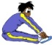 Pike
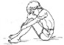Tuck
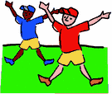Straddle
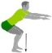Squat
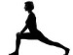Lunge
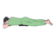Prone
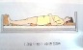 Supine

Name __________________________________________________Class___________________
Body Positions

Straight
Pike
Tuck
Straddle
Squat
Lunge
Prone
Supine

Full Name_____________________________________________________Class___________________
Body Positions
______________________________
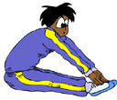 ______________________________
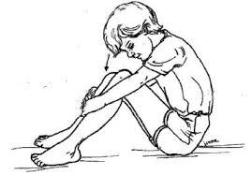 ______________________________
______________________________
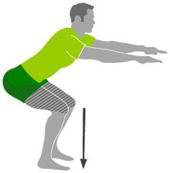 ______________________________
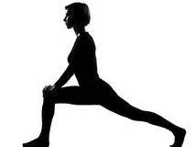______________________________
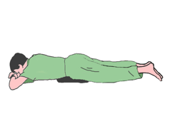 ______________________________
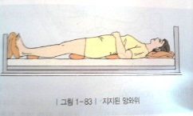 ______________________________

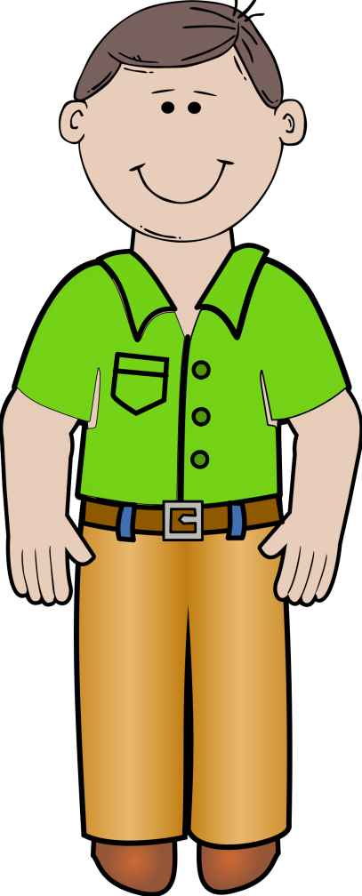 Straight

Pike

Tuck

Straddle

Squat

Lunge

Prone 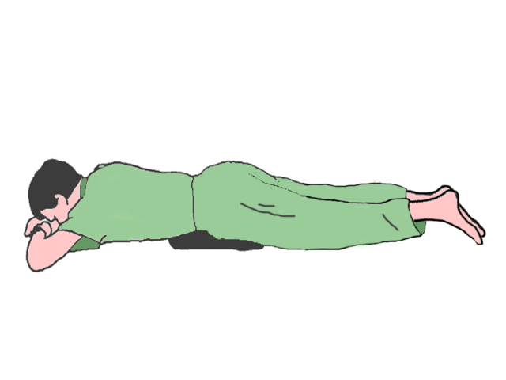

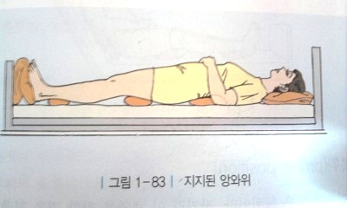 Supine
Straight
Pike
Tuck
Straddle
Squat
Lunge
Prone
Supine

